Fr. Conceicao Rodrigues College of Engineering



Web-Genie
FullFill your work with just one click

Group ID : D6

Group Member :
9409 - Gladys Gince Skariah
9459 – Mirza Mohammed Junaid

Co-ordinator :
Unik B. Lokhande

Index

Topic Pg No

Problem Statement 3

Abstract 3

Technology Used 4

Problem Statement

Many Web Developers have problem to write the same code / tags again and again , It is very time Consuming , seeing this Problem we have Introduce
WebGenie – FullFill your work with just one click .

Abstract

WebGenie is a Application developed in Python , Helps Developer to Not write the Same Code again and again & Developer and can easily write code in just one click. Developer can generate code in HTML, CSS & JAVASCRIPT or can use simple Text Editor. WebGenie is Simple,Lite & User-Friendly Application .

Technology Used

Programmin Language :
Python

Libraries :
Tkinter
PIL – python imaging library

Modules :
OS
WebBrowser
Regex

Overview

Interface
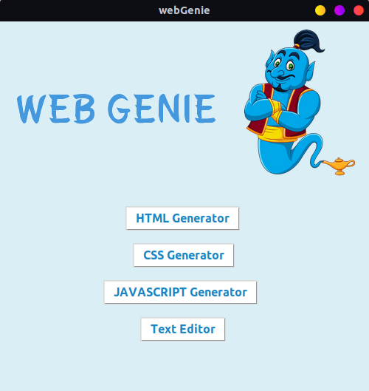

HTML GENERATOR
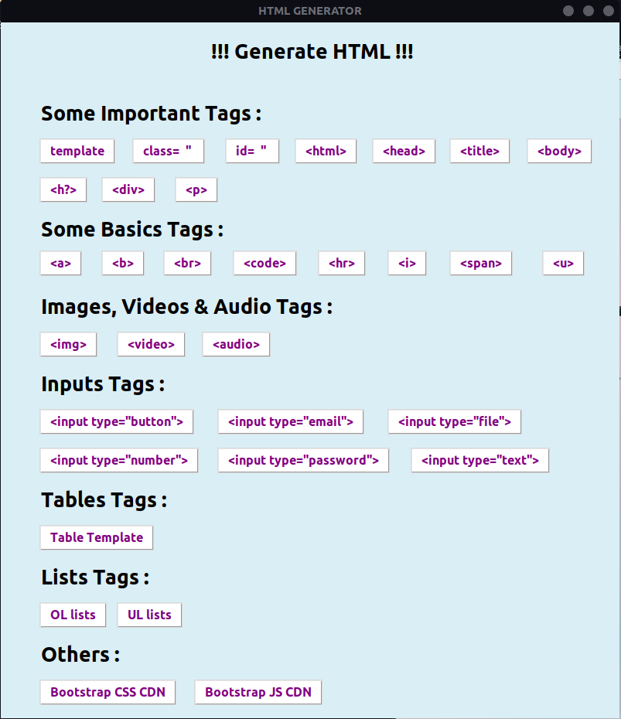

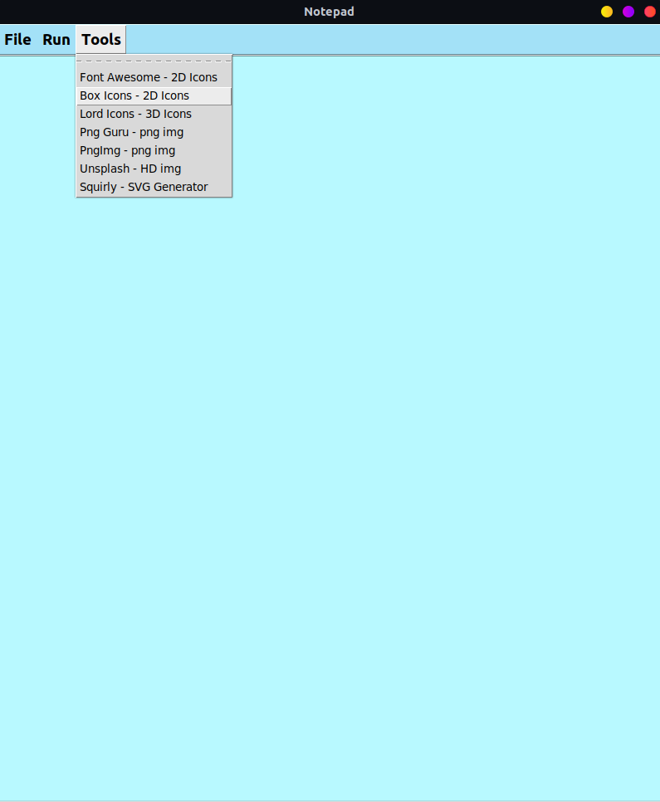

CSS GENERATOR

